Welcome to Grade 11 IB Students

September 2023

Welcome to Saint John Paul II and the
International Baccalaureate Diploma Programme!

As grade 11 students, you are in what IB refers to as your “anticipated year”. This year you will be working your way through the requirements of your IB streams, culminating with the SL French B exams! Here is some information to help you and your parents get acquainted with the programme.

IB Courses:
As a reminder, throughout this year, you should have 8 courses total and all of these courses are at the IB level. All students will be taking the following courses:
- Grade 11 English ENG3U5 and Grade 12 English EWC4U5
- Grade 11 French FSF3U4 and Grade 12 French FSF4U4
- Grade 12 Math MHF4U4
- And the rest of your courses are dependent on your stream which will include some of the following: History of the Americas, Biology, Chemistry, Visual Arts, Music.
- If you are taking a course at the Higher Level (3 maximum), they will end with a “5”
- If you are taking a course at the Standard Level (3 maximum), they will end with a “4”
- The IB CORE - Theory of Knowledge, Creativity Activity and Service and Extended Essay will be introduced throughout the year
- More details on each of these things to follow

Communication:
We need to establish some lines of communication. We use www.sjpii.ManageBac.com to communicate with students. All grade 11 students have an account on our IB platform management system, ManageBac. Students will be able to track and upload materials for the IB Core, TOK, EE and CAS. It will also be a way for students to communicate with their EE supervisors and for the IB Coordinator and EE/CAS Coordinator to post messages regarding all things IB - volunteer opportunities, IB materials, dates, and activities. If you have any questions about this system, please let us know. We pay for these accounts,so please make use of them. They are a time saver.

IB Fees
For your Grade 11 year, $400.00 is due this year for Grade 11 Students. This covers your registration and IB French exam fees. Many of you have already paid $200.00, and will only owe the remaining $200.

All payments this year will be done through school cash online. Attached to this welcome package is a written explanation of how to set up your account. You will notice that you can pay in installments - with the amounts of $50, $100 or the full amount of $400.

Some amount must be paid by October 31, 2023 in order for us to register you for IB this year. IB registration must be completed by November 15, 2023 and no student is registered unless they have contributed something (does not need to be the full amount).

Any family who has concerns about this should speak with Ms. Scotula Navaratnasingham, the Principal.

Additional Materials Attached:
- School Cash Online pamphlet
- CAS
- EE
- Academic Honesty pamphlet / declaration (must be signed and returned by Sept. 29/23)
- Table of Equivalents
- IB acronyms

We look forward to meeting you and working with you throughout this year. Please get in touch with us at stephanie.silliker@tcdsb.org or suzanne.regimbal@tcdsb.org or call the school at 416 393 5531 to leave a message with the secretaries and we will respond as quickly as we can to your inquiries.

We would like to wish everyone a healthy, happy and successful year!

Stephanie Silliker and Suzanne Regimbal
SJPII IB DP Coordinators

Additional Materials:
Introducing SJP II IB Website!
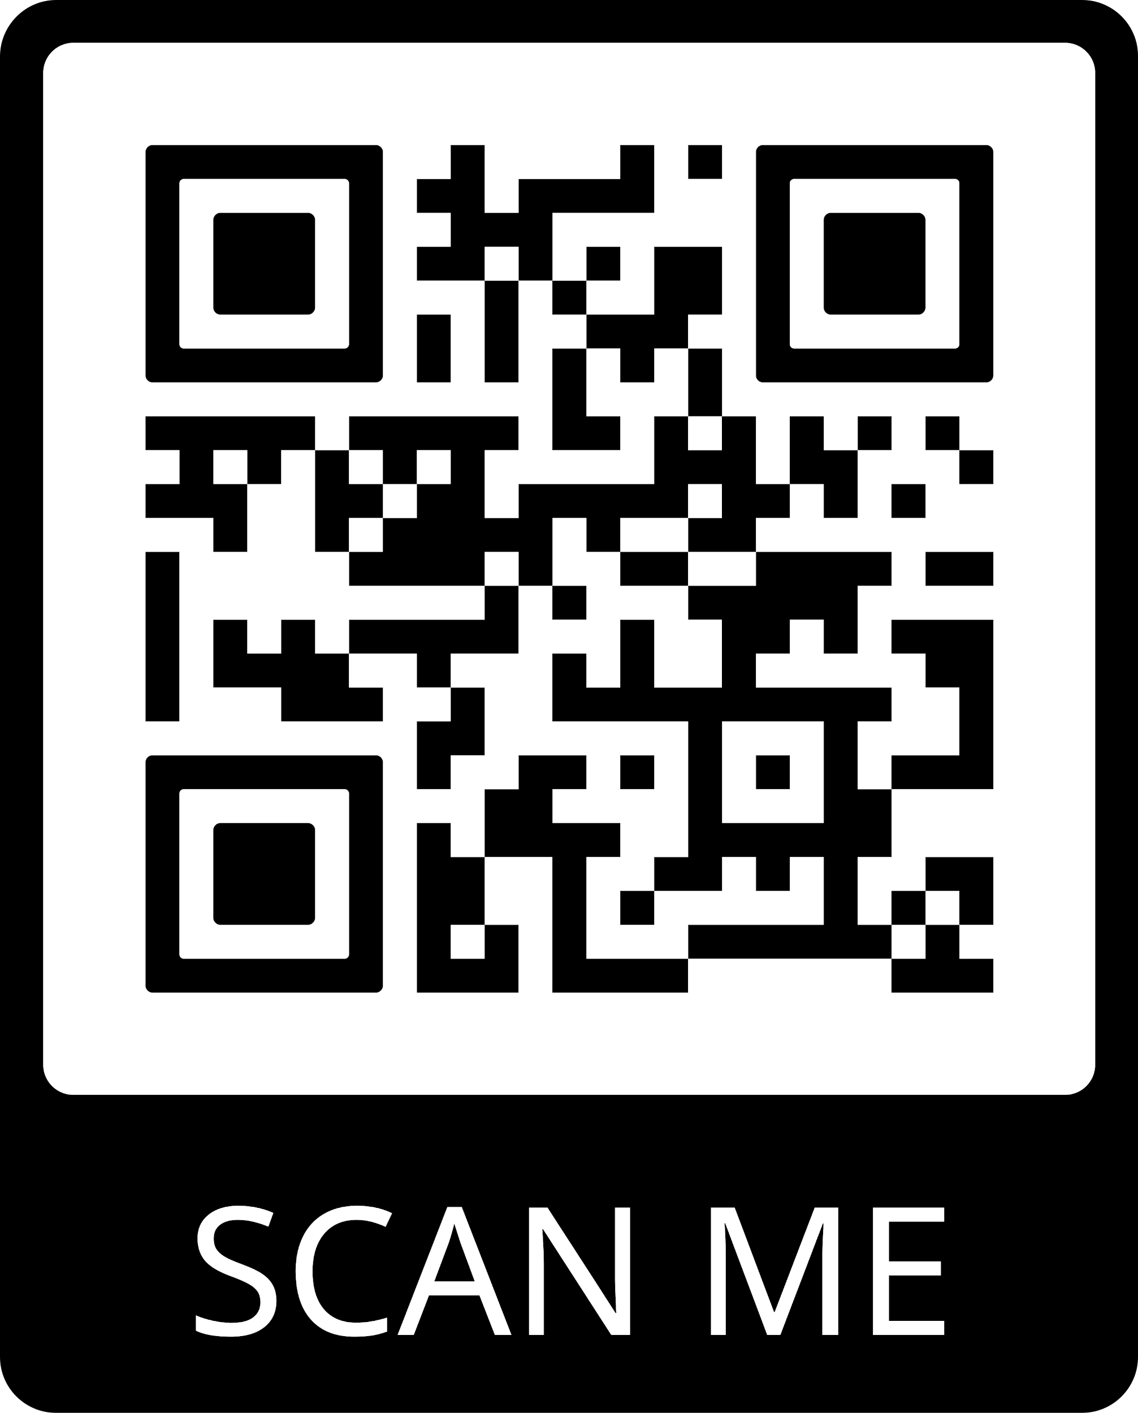
CAS Legacy project by Allison Oldfield, IB Grad 2019, currently supervised by Sara Pollanen, IB Class 2021
Link:http://www.ibstjohnpaulii.com/

Link to Grade level assemblies - Grade12
https://drive.google.com/file/d/15D3A5Iz24jw0dxXoKxMf3ZHv61IoQZJh/view?usp=sharing

Link to a list of materials every IB Student should have (created by IB graduating class 2020)
IB_HANDBOOK___List_of_materials_every_IB_student_should_have

Link to tips every IB student should know before completing the IB program (created by IB graduating class 2020)
https://drive.google.com/file/d/1mtQOQQntWD29Xsj2VC2PZDbImH6kdu3u/view?usp=sharing

Link to a video testimonial from an IB grad, 2020, on the benefits of IB
https://drive.google.com/file/d/1lVXOXdz0YgI_ofCIjg35FxsqkIT1diYw/view?usp=sharing

Links to support materials on approaching teachers (created by the IB graduating class of 2020)
https://drive.google.com/file/d/1bb4_ti_s7v2xytGVDHCCKL2032LuswEo/view?usp=sharing

Links to support materials on time management (created by the IB graduating class of 2020)
https://drive.google.com/file/d/17-D_M8RTcgTw-bFaBU_5eTMn-_c_0A9L/view?usp=sharing

Links to support materials on stress management (created by the IB graduating class of 2020)
https://drive.google.com/file/d/1d396zBn_dvF1xu46CKlhyValLnUgsS7V/view?usp=sharing

Links to support materials on the benefits of IB (created by the IB graduating class of 2020)
https://drive.google.com/file/d/1DxtrjTPK9XWx01WA056ULZGd1TWq_BIM/view?usp=sharing

The How-Tos of OPCVL for History
https://docs.google.com/document/d/1VgF3Hio7gwulzKcX18CvIcKbeb8NBjp3Rj7LkXCrJQc/edit?usp=sharing

The No-Nos of IB
https://docs.google.com/document/d/1mVM-qnAXPFE2Ap6UdIx7RTf91ngTNMuuwWbQV9332JA/edit?usp=sharing

English SCASI Notes
https://docs.google.com/document/d/1SS4ejE-LJkAFPm8KjFC8frsMJRU6w1kKpo9GF1VnfNI/edit?usp=sharing

Table of Equivalents
https://docs.google.com/document/d/1HrqxAwM9mxDZB5Iqlcsed-lztqq3lSj8HbpPsiiZcJ4/edit?usp=sharing

Helpful Online Resources for IB
https://drive.google.com/file/d/181L7v9Jen7ot0v2Iyo7hXxEyoAqTQ9Se/view?usp=sharing

Academic Honesty Pamphlet
https://dochub.com/robertt-z9nniz/YpDBonNVrxov7NYRMX93r7/copy-of-copy-of-academic-honesty-pamphlet-pdf?dt=Bt7HuivG1DkFTyTF8z8p

School Cash Online
https://drive.google.com/file/d/1lvfG-7GjbI01jdE4sGk6iaRAhDFoo-us/view?usp=sharing

