STARTING IB:
A Resource for Information and Preparation for the IB Program
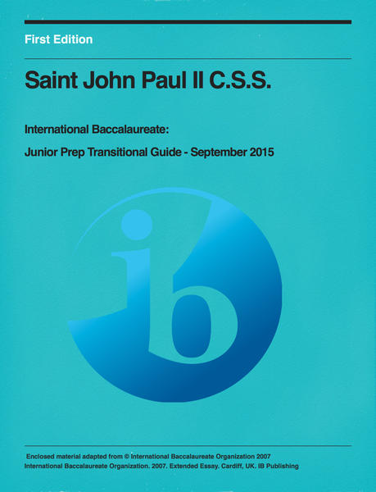

An iBook created by: Suzanne Regimbal, Stephanie Silliker and Rachel Vigliatore
This is an interactive, multi-faceted resource for students starting in the Junior Prep IB Program. It details all aspects of the program but especially the ideals of self regulation, activism and international mindedness.
The book should also be seen as a resource for schools that are looking at starting an IB program and wanting ideas about structures and possible solutions to challenges that can arise. There are examples given, taken from different IB schools in the hopes of offering insight to the intricacies of the program.
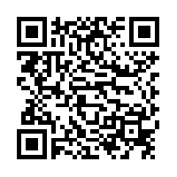
Scan this QR Code to find the book on the iBook Store:

