Grade 10 IB 2021/2022
IB Pathways – Grade 11 and 12
Life Science | Business / Commerce |  | Engineering | General Arts
English | English |  | English | English
French | French |  | French | French
History | Business Management |  | Business Management | History
Biology | Biology |  | Physics | Biology
Math | Math |  | Math | Math
Chemistry | History/Visual Arts/Music |  | Chemistry | Business/Visual Arts/Music
Future Topics to Share with You VIRTUALLY  Table of Equivalents  Demystifying the IB Core (CAS, EE, TOK)  Myth vs. Reality in IB  Mentorship with Grade 12s  Study Habits and Test Taking Skills |  |  | 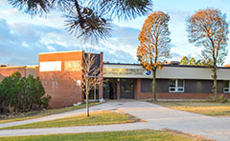
IBSO Table of Equivalents  7 97-100  6 93-96  5 84-92  4 72-83  3 61-71  2 50-60  1 Below 50  Applied to all Grade 11 and 12 IB assessments. |  | School IB website  A resource for IB students at Saint John Paul II. Please visit us at  https://www.ibstjohnpaulii.com/
At SJP you will pay $1100 over grade 11 and 12 for an IB education.  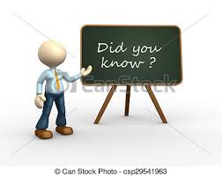  If you attended Upper Canada College, you would pay $52,000 per year. If you attended Branksome Hall, you would pay $44,000 per year. Same education. Different price. You do the math! |  |  |  | Learner Profile
 |  |  |  | IB Wants you to be:
Inquirers, Thinkers, Knowledgeable, Caring Communicators, Open-Minded, Risk-Takers, Balanced, Principled, Reflective
And so do we!

